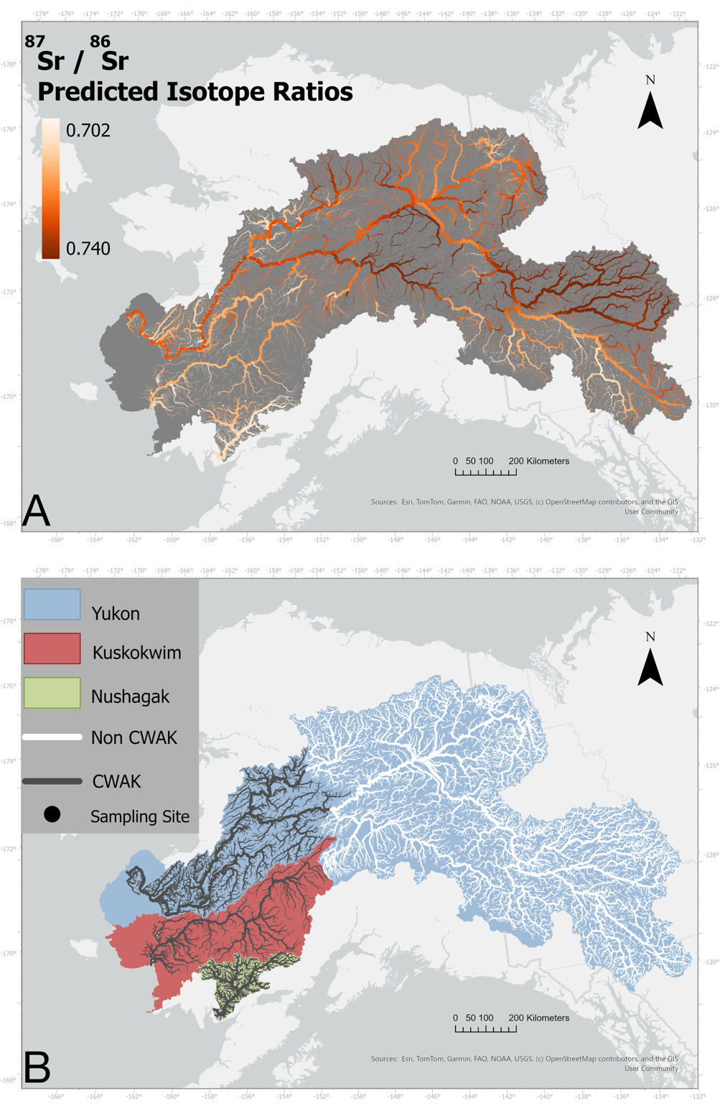
Figure 1:
A) Three major river systems in Western Alaska, the Yukon (Blue), Kuskokwim (Red), and Nushagak (Green) watersheds. Black circles indicate sampling locations for otolith collection (and genetic collection in the Yukon) on each river.
B) ⁸⁷Sr/⁸⁶Sr Isoscape of all three river-basins. Values range from 0.702 to 0.740, with darker colors indicate more enriched values whereas lighter colors indicate less enriched.

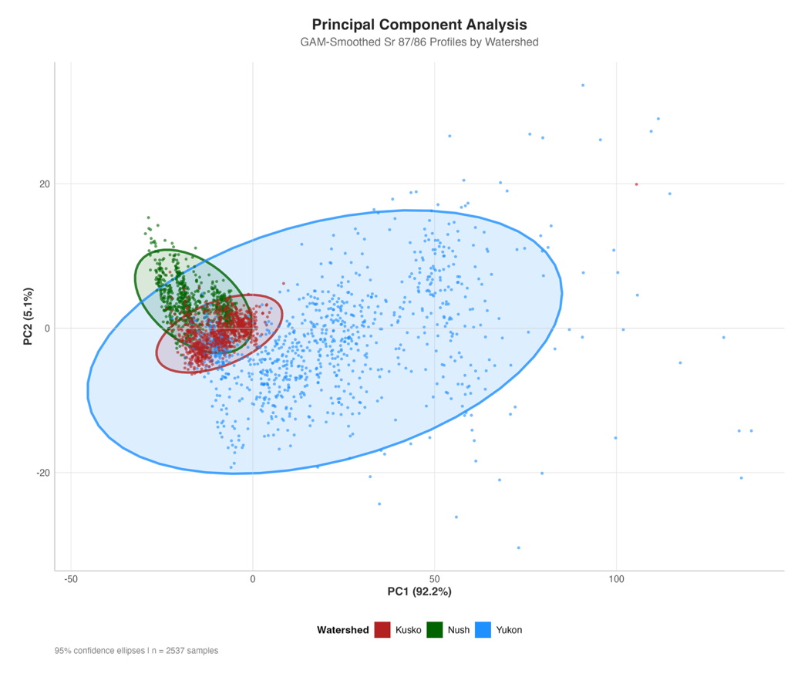
Figure 2: Principal Component analysis of GAM smoothed timeseries data (n = 2,531 otoliths). Significant clustering is evident, but with overlap between all watersheds. Yukon (Blue points) contain a much larger range of values, indicative of the large range in natal ⁸⁷Sr/⁸⁶Sr values in the basin. Kuskokwim (Red points) overlap between both Nushagak and Yukon fish, likely due to its position in the region between both watersheds.

Figure 3: A) Principal component analysis of all samples with a natal origin ⁸⁷Sr/⁸⁶Sr of 0.7080 - 0.7085. Clustering among watersheds is evident between principal components 1 and 2 (68.39% of variance), as well as between principal components 2 and 3 (31.16% of variance). There is some overlap between all three watersheds in both cases. B) Sample otolith LA timeseries colored by the absolute value of the PCA loadings at associated timeseries indices. PC1 (top row) shows high loading on the middle section of the timeseries after the natal origin region. PC2 is driven by the region of the timeseries towards the marine entry, likely the result of mainstem migration to the ocean. Separation along PC3 is driven by the very beginning of the timeseries, which is the region associated with the natal origin. Notably, Yukon individuals from the CWAK region contain a less pronounces mainstem signal as compared to their counterpart from the upper or middle Yukon genetic groups.

Figure 4: Model Performance comparison among data preprocessing steps and model types. Accuracy indicates the proportion of each class correctly classified. F1-Score is the harmonic mean of precision and recall, providing a balanced performance measure across all watershed classes. Results compare two ⁸⁷Sr/⁸⁶Sr timeseries smoothing methods (GAM, MA) and three machine learning algorithms (Random Forest, SVM, KNN) using either all test data (Total) or only overlapping isotope ranges (Restricted). Darker green colors indicate higher scores.

Figure 5: Confusion matrix from the highest performing model (Random Forest on GAM Smoothed data) for both total test set and overlapping subset. Boxes along the horizontal axis indicate correctly classified individuals (red). Vertical axis labels are the actual watershed labels whereas horizontal labels are the predicted class from the model. Percentages indicate the percent of the actual class identified as the predicted class and numbers indicate the number of the actual class assigned to the predicted class.

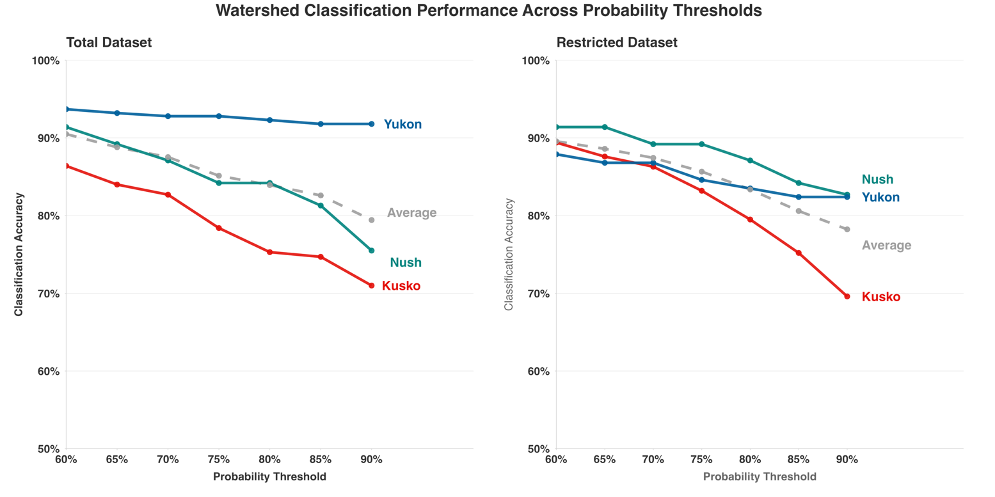
Figure 6: Classification accuracy with different probability thresholds (60-90%). Points indicate the percentage of correctly classified individuals with a calibrated probability value above the given threshold value. Grey dashed lines represent the overall accuracy, whereas colored lines illustrate the class-specific probability at that threshold

